Copyright © 2011 American Scientiﬁc Publishers
All rights reserved
Printed in the United States of America

Advanced Science Letters
Vol. 4, 3398–3402, 2011

Planar Field Emission Current from
Individual Carbon Nanotubes

Cheng-Kuang Huang, Rui Zhu, Qiang Fu, Qing Zhao∗ , and Dapeng Yu∗

State Key Laboratory for Mesoscopic Physics and Electron Microscopy Laboratory, Department of Physics, Peking University, Beijing 100871, People’s Republic of China

Carbon nanotube (CNT) planar ﬁeld emitters were fabricated on a SiO2 /Si substrate. The anode, cathode and CNT all lay on the same substrate for the promising advantage of intergratibility with planar technology. The emission current was acquired in a scanning electron microscope (SEM). Despite the asymmetry (tip-electrode) of our ﬁeld emission sample, a symmetrical I –V curve consistent with the Fowler-Nordheim theory was acquired. Using Zener theory on quantum tunneling in insulators, the observed phenomenon was explained to be a possible leakage current through the insulating SiO2 instead of real ﬁeld emission. Moreover, the simulated local electric ﬁelds at the emitter apex exclude the possibility of an accountable emission current. Our results are of great importance in studying planar ﬁeld emission since it draws attention to avoid mistaking leakage current for the actual ﬁeld emission current in planar ﬁeld emission devices.

Keywords: Planar Field Emission, Carbon Nanotube, Leakage Current, Zener Tunneling, Finite Element
Method.

1. INTRODUCTION
The ﬁeld induced emission of electrons from cold cathodes is a well understood phenomenon and is, at present, still an active research area for many one-dimensional nanowires and nanotubes.1–8 Two important parameters determining the perfor- mance of a ﬁeld emitter: the radius of curvature of the emitter tip, and the aspect ratio of the emitter: generally, the sharper the emitter, the better the ﬁeld emission properties. Carbon nano- tubes (CNTs) are obviously the most prospective candidates as ﬁeld emitters with the very small radius curvature of the tip on nanoscale and very large aspect ratio. Acknowledging this, CNT ﬁeld emitters have drawn much attention lately, and have been demonstrated to have outstanding ﬁeld emission properties.9–15
They are shown capable of delivering 1 A per single CNT and high current density in excess of 1 A/cm2 .
Most of the pioneer works on the CNT ﬁeld electron emitters were designed within the framework of the traditional vacuum tubes. The three-dimensional tip-to-electrode setup was adopted; the anode and the cathode are separated by a high vacuum empty space (Fig. 1(a)). Planar ﬁeld emission in general, is the ﬁeld emission achieved on and/or across a substrate; it is character- ized by the fact that the cathode, the anode, and the emitters lay on an insulating substrate.16 So the electron emission is reduced from three-dimensional to two-dimensional. Figures 1(b) and (c) illustrates these planar devices: (b) is the so called tip–tip (or

∗ Authors to whom correspondence should be addressed.
bilateral) conﬁguration and (c) is the tip-electrode (or unilateral) conﬁguration. The beneﬁts of such a design include usage of thinner CNT emitters, integratability with planar technology, sta- ble construction, and etc. The concept is ideal for the incorpora- tion of emitter devices into integrated circuits. However, it is only until recently—with the development of nanotechnology and the advent of sophisticated instruments and fabrication techniques— that devices based on the idea were realized.17
Many recent reports on planar ﬁeld emission have chosen to assemble the emitter and electrodes on doped Si wafers with a SiO2 insulating layer (typically a few hundred nanometers in
thickness).16 18–22 Employing such constructions, a gate voltage
can be applied, which can increase the functional options of the ﬁeld emitter device. The inherent problem with such a construc- tion is that leakage current through the insulator is very easily neglected. In this report, a signiﬁcant leakage was found in the insulator layer in our planar ﬁeld emission device based on indi- vidual CNT. Furthermore, the I–V relation closely resembles that of ﬁeld emission with similar Fowler-Nordheim (FN) plots. Thus, one can easily mistake the obtained current for actual ﬁeld emis- sion phenomenon. Possible reasons were carefully analyzed for the observed results. And suggestions were given in order to con- ﬁrm the experimental data to be real ﬁeld emission.

2. EXPERIMENTAL DETAILS
The CNTs in this investigation were grown via a chemical vapor deposition (CVD) method23 on a pre-marked, highly doped,

RESEARCH ARTICLE
3398 Adv. Sci. Lett. Vol. 4, No. 11/12, 2011 1936-6612/2011/4/3398/005 doi:10.1166/asl.2011.2049

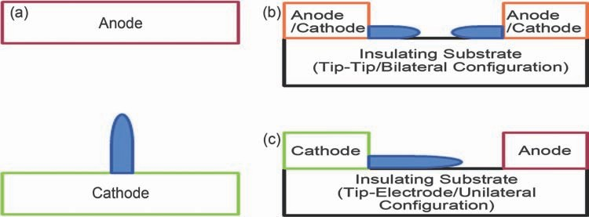

Fig. 1. An illustration of a traditional vacuum ﬁeld emission setup characterized by two topologically separated electrodes. (b) and (c) are two possible conﬁgurations of a planar ﬁeld emission device: (b) with two opposing emitter is the tip–tip (or bilateral) conﬁguration. And (c) with only one emitter is the tip-electrode (or unilateral) conﬁguration; the planar devices are characterized by the fact that the electrodes share a common substrate.

Si substrate covered with a 500 nm SiO2 insulating layer. This method produces roughly straight CNTs lying along the same direction, convenient for producing planar ﬁeld emitters. Figure 2(a) is the SEM micrograph of the as-grown CNT on the premarked substrate.
For the measurement of ﬁeld emission current, Ti (20 nm)/Au (30 nm) electrodes were deposited on the individual as-grown CNTs using standard electron beam lithography (EBL) and lift- off process. Similar to the work previously reported,16 sharply tipped glass needles were employed in cutting the CNT under an optical microscope (Fig. 2(b)). Our procedures produced a tip-electrode planar CNT emitter like those illustrated in Figure 1(c); the surface morphology of the prepared CNT emitter
was characterized with an atomic force microscope (SEIKO SPI3800N) under contact mode (Fig. 2(b)). The CNT emitter apparently folded back upon itself at the tip; the surface analysis of an uncoupled part (blue arrow) and the apex (red arrow) of the emitter reveals a diameter of ∼3.6 nm (blue box) and ∼3.9 nm (red box) respectively. Hence, considering uncertainties and the coupling, the apparent apex diameter is estimated to be ∼9 nm. The length of the emitter is approximately 2.6 m; therefore, giving an aspect ratio of about 289.
I–V measurements of the planar ﬁeld emission current on the individual CNT were conducted in a SEM chamber under a vac- uum of 2 × 10−6 Torr. A Keithley-6430 Sub-Femtoamp Remote SourceMeter together with its pre-ampliﬁer was used to apply

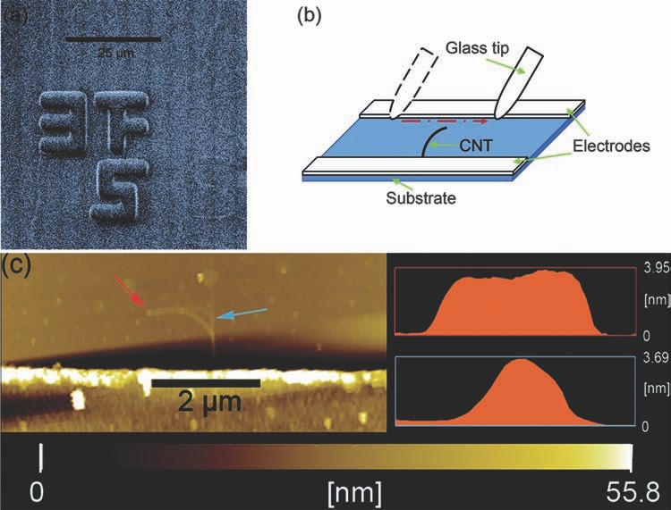

Fig. 2. The SEM micrograph of the as-grown CNTs, laying alone the same direction on the SiO2 /Si substrate. (b) An illustrated demonstration showing CNT emitters readily fabricated with the use of glass needle tips under an optical microscope. (c) AFM micrograph of our prepared CNT emitter: the color boxes are surface analysis, they correspond to the site of the color arrows on the image. The CNT diameter is ∼3.6 nm (blue box), however, due to a folding back of the CNT at the tip, the apparent diameter is over twice the actual CNT diameter (red box).

3399

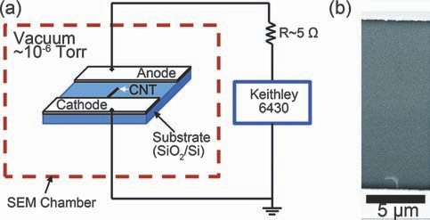

Fig. 3. An illustration of the measurment setup in a SEM with a vac- uum environment of 10−6 Torr; a keithley-6430 Sub-Femtoamp Remote SourceMeter was used to source the voltage and measure the current. (b) The SEM micrograph of the tested planar CNT emitter before current acquisition.

the voltage and measure the emission current; the voltage was ramped in steps of 1 V. The peripheral circuit resistance of our setup was less than 5 Ohm. The electron beam was ini- tially used to determine the tip-electrode distance (∼14 m) then subsequently turned off for the emission current acquisition. Figure 3(a) is a schematic illustration of the current measurement setup, and the SEM micrograph of the tested planar CNT emitter is shown in Figure 3(b).

3. RESULTS AND DISCUSSION
Figure 4(a) shows the measured I–V curve: the forward curve is the obtained current when a negative bias is applied on the emitter part and the reverse curve the vice versa. The onset volt- age at 1 nA was around 10 V. Comparing the results to the
115 V onset voltage of a similarly thin traditional single CNT emitter, with a tip-electrode distance of a mere 1 m, reported by Bonard et al.,11 the apparent improvement of ﬁeld emission properties is quite signiﬁcant. The onset voltage of our planar CNT emitters is much smaller than most of the reported CNT emitters in traditional setups.11 24–26 The obtained I–V implies a bilateral emission in nature; it bears resemblance to that previ- ously obtained from a tip–tip conﬁguration in planar ﬁeld emis- sion devices by Song16 and Wang.27 Moreover, complying with the Fowler-Nordheim theory,28 29 the FN plot (inset of Fig. 4(a)) of the curve does reveal a linear trend at emission ﬁeld strengths. So if it is real ﬁeld emission, the improvement is signiﬁcant. However, considering the fact that an asymmetric tip-electrode conﬁguration was deliberately prepared (Fig. 1(c)), the result seems absurd, since it should give current only when negative bias was applied on the CNT, and no emission current when positive voltage was applied. The symmetric shape of the curve

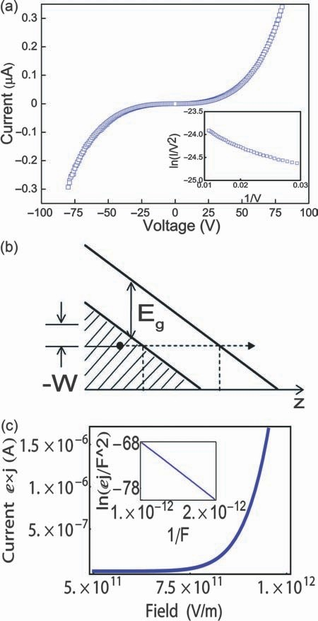

Fig. 4. I–V curve acquired from the planar CNT. The forward curve is in the sense that a negative bias is applied on the emitter. The inset shows the corresponding FN plot of the emission data; the linearity complies with the FN theory. (b) is an illustration of an electron with energy −W tunneling through the ﬁeld tilted bands; Eg is the band gap (here, analogous to the work function (c) is the current (ej), calculated from Zener’s expression, tunneling into the conduction band versus the applied ﬁeld; the inset shows the corresponding FN plot.

F is conventionally written as: F = V /d: V is the applied volt- age, is the geometric enhancement factor, and d is the tip- electrode distance. The law relating I and F is thus written as29
makes us assume a leakage current might exist between the elec-
1 5 × 10−6 V

2 exp
10 4

× exp
6 44 × 109 1 5d
−
trodes through the insulating SiO2 layer, for leakage current is
independent of the direction of bias voltage. Nevertheless, this
I = A d
V
(1)
alone cannot account for the consistency of the I–V with ﬁeld
emission theory.
The FN ﬁeld emission theory is basically the rationalization of the quantum tunneling phenomenon.28 The theory has been proved useful in describing the relationship between the ﬁeld emission current I and the local ﬁeld F at the emitter surface.
where A has the dimension of an area m2 and is the work function in eV of the emitting material. From Eq. (1) it can be observed that if ln I /V 2 is plotted against I/V , then, at emis- sion ﬁeld range, one will arrive at a linear function with a slope
−6 44 × 102 1 5 d/ ; this is the so called FN plot. By ﬁtting the
experimental data in a FN plot, either or the ﬁeld enhancement

3400

Adv. Sci. Lett. 4, 3398–3402, 2011

factor can be determined. Usually it is the enhancement factor that is calculated for, since it is a measure of emitter performance. The FN plot has also been used over the past as a supporting evidence for ﬁeld emission. Despite this, the following paragraph will prove it to be only a necessary condition for ﬁeld emission. Returning to the question at hand, with the FN law in mind, our observed current should also be expressible in a relation sim- ilar to Eq. (1) to show such analogous behavior as ﬁeld emission. In fact, the phenomenon is known as internal ﬁeld emission of insulators; it was ﬁrst treated by Zener in 1935.30 The idea is basically shown in Figure 4(b), an energy level versus position illustration for insulators or semiconductors with a band gap Eg between the valence and conduction band. Upon application of an electric ﬁeld, the band gap edges become tilted in space. An electron with energy −W with respect to the valance band edge can make transitions to the conduction band not only vertically (requiring an energy > Eg + W ), but also horizontally, owing to the applied ﬁeld. Namely, the valence electrons can tunnel into a current carrying band state. The expression derived limiting the rate of transition is, as expected, an exponential. It is written as
RESEARCH ARTICLE

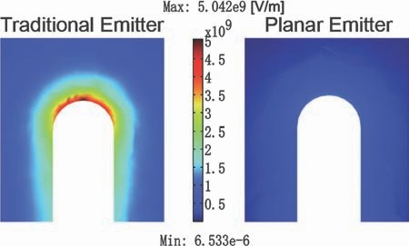

Fig. 5. The slice plot of calculated local ﬁelds for both conﬁgurations. As it is shown, for the traditional conﬁguration the tip ﬁeld is around 5 times larger than the planar setup.

a single standing CNT: 1.45 m in length, a 7.5 nm radius, and an approximately 1 m tip-electrode distance. Meanwhile, the model bent CNT for planar conﬁguration in our case, lying on a 500 nm thick SiO2 , is 5 nm in radius and roughly 2 m long
eF a
j exp
=
h
2 ma 2
− h2 ∗eF ∗
(2)
with a tip-electrode distance of about 14 m. A hemispherical
cap was drawn to model the tip head for both cases. The volt- age applied on the emitter is chosen as 115 V so as to model
where a is the spatial periodicity of electron potential energy,
m is the electron mass, Eg is the energy band gap, and F is the applied local ﬁeld. Intuitively, the electric ﬁeld F here can also be related to the applied voltage through an analogous enhance-
the onset voltage (the voltage required to extract a current of
1nA) reported by Bonard et al.11 The calculated ﬁeld at the apex of the free standing model and planar model was ∼5 × 109 and
9
ment factor. Figure 4(c) is a plot of current I (electronic charge
∼1 × 10
V/m respectively (Fig. 5). The electric ﬁeld at the apex

e × Eq. (2)) versus electric ﬁeld considering reasonable values for the parameters in our experimental setup: a = 50 × 10−9 m (pre- suming thinner amorphous SiO2 at leakage sites) and Eg = 9 1 eV for SiO2 ; the calculation is a periodic boundary estimation using the thickness of the amorphous SiO2 as a large unit cell. The curve thus obtained share similarities with that of vacuum ﬁeld emission. To show this curve will derive a similar linearity in a FN plot, Eq. (2) is rewritten as
of the CNT in planar conﬁguration is only ﬁfth of that in free
standing conﬁguration. In other words, the onset ﬁeld for vacuum ﬁeld emission in our case was not achieved, so the obtained I–V curve could not be vacuum ﬁeld emission, in accordance with our previous explanation.
Although we have proved the current to be of leakage through the insulating layer, the origin of such a large leakage is difﬁ- cult to identify. Repeated experiments with or without CNT do not always reveal signiﬁcant leakage current within the voltage
ej
ln

= ln
e2 a
−
2 ma 2

(3)
source range (200 V): there are cases where a relative ﬂat curve
(no current) is obtained and sometimes the phenomenon is trig-
F 2 Fh
h2 ∗eF ∗

gered by a breakdown ﬁrst. The evidences suggest that leakage
Contrary to FN law, the leading part of the right hand side of Eq. (3) (ln e2 a/F h ) is here also a function of local ﬁeld; one would expect to see a non-linear relation. Nonetheless, the plot of Eq. (3) (Fig. 4(c) inset) does still reveal a linear relation. The reason for this is that the variation of ln e2 a/F h is small within the ﬁeld range of observable Zener tunneling. Within this ﬁeld range, ln e2 a/F h varied 1 ∼ 0 7 whereas the second term
2 ma 2 /h2 ∗eF ∗ varied 2 ∼ 13 3 ; the former is only about
5.2% of the latter. So when we plot ln ej /F 2 against −1/F
as shown in inset of Figure 4(c), a linear relationship similar as FN plot was obtained. This is the main reason for mistaking the obtained linear “FN plot” for real vacuum ﬁeld emission tun- neling. In fact, it is the leakage current through SiO2 insulating layer explained in the framework of Zener Theory. This result supports our initial assumptions and speculations.
To complete our analysis, the electric ﬁeld at the CNT tip is calculated using Comsol Multiphysics, a commercial program based on ﬁnite element method, is employed. For a quantita- tive comparison, a traditional conﬁguration was considered along with the conﬁguration in this study. The dimension in the tradi- tional case closely follows those reported by Bonard et al.11 on
may be due to defects in the insulating layer, local sites where the SiO2 is thinner. The defects may be originally present from fabrication process or introduced by material breakdown from local static charge accumulation. It is also reasonable to assume breakdown from the applied ﬁeld through a ﬁeld enhancement mechanism analogous to the vacuum ﬁeld emission situation.
Our results and analysis suggest, where the FN theory is appli- cable, the linearity of FN plot is only a necessary condition (at least in planar emission setups) for real ﬁeld emission; other tests must be performed in order to conﬁrm the results. For uni- lateral assemblies, a reproducible asymmetric I–V curve, from negative to positive bias should be sufﬁcient. Meanwhile, for symmetric bilateral assemblies, leakage between electrode and Si wafer must be re-examined after observing a supposed vacuum ﬁeld emission.

4. CONCLUSIONS
Carefully designed CNT planar system for ﬁeld emission was fabricated. Utilizing SEM to provide the vacuum and precise measurements, a planar ﬁeld emission current from the planar

3401

RESEARCH ARTICLE Adv. Sci. Lett. 4, 3398–3402, 2011

CNT was observed. The obtained I–V was symmetric for for- ward and reverse bias and the FN plot complied with the FN theory. But our tip to electrode experimental setup should give asymmetric I–V curve instead of a symmetric one. Finite ele- ment calculations of our planar device revealed the fact that the onset ﬁeld strength for vacuum ﬁeld emission was not achieved. Thus the current cannot be originated from the CNT. Meticulous analysis based on Zener theory reveals the current to be origi- nated from leakage through the insulating SiO2 layer instead of real vacuum ﬁeld emission phenomenon. The large leakage was attributed to possible defects in the SiO2 layer.
One of the aims in studying planar ﬁeld emission is its prospects in integrated circuits. Our work is of great importance in studying ﬁeld emission from planar ﬁeld emission devices since it is easy to mistakenly identify the obtained current to be originated from vacuum ﬁeld emission instead of other possible cases such as leakage from insulating layer.

Acknowledgments: This project is ﬁnancially supported by the National Natural Science Foundation of China (NSFC 50902004 and 11023003), and National 973 projects (No. 2007CB936202, 2009CB623703, MOST) from China’s Ministry of Science and Technology and the Research Fund for the Doctoral Program of Higher Education.

References and Notes
7. Q. Zhao, X. Y. Xu, X. F. Song, X. Z. Zhang, D. P. Yu, C. P. Li, and L. Guo,
Appl. Phys. Lett. 88, 3 (2006).
8. X. T. Zhou, H. L. Lai, H. Y. Peng, F. C. K. Au, L. S. Liao, N. Wang, I. Bello, C. S. Lee, and S. T. Lee, Chem. Phys. Lett. 318, 1 (2000).
9. A. G. Rinzler, J. H. Hafner, P. Nikolaev, L. Lou, S. G. Kim, D. Tomanek, P. Nordlander, D. T. Colbert, and R. E. Smalley, Science 269, 5230 (1995).
10. W. A. Deheer, A. Chatelain, and D. Ugarte, Science 270, 5239 (1995).
11. J. M. Bonard, K. A. Dean, B. F. Coll, and C. Klinke, Phys. Rev. Lett. 89, 19
(2002).
12. J. M. Bonard, C. Klinke, K. A. Dean, and B. F. Coll, Phys. Rev. B 67, 11
(2003).
13. J. T. H. Tsai and J. G. S. Li, Ieee Electron Device Letters 29, 7 (2008).
14. Z. L. Wang, R. P. Gao, W. A. de Heer, and P. Poncharal, Appl. Phys. Lett.
80, 5 (2002).
15. C.-D. Kim, H.-S. Jang, S.-Y. Lee, H.-R. Lee, Y.-S. Roh, I.-S. Rhee, E.-W. Lee, H.-S. Yang, and D.-H. Kim, Nanotechnology 17, 5180 (2006).
16. X. F. Song, J. Y. Gao, Q. Fu, J. Xu, Q. Zhao, and D. P. Yu, Nanotechnology
20, 40 (2009).
17. H. H. Busta, Institute of Physics Conference Series 99, 29 (1989).
18. A. S. Teh, S. B. Lee, K. B. K. Teo, M. Chhowalla, W. I. Milne, D. G. Hasko, H. Ahmed, and G. A. J. Amaratunga, Microelectronic Engineering 67–68, 789 (2003).
19. K. Subramanian, Y. Wong, W. P. Kang, J. L. Davidson, B. K. Choi, and
M. Howell, Diamond Relat. Mater. 16, 12 (2007).
20. Y. M. Wong, W. P. Kang, J. L. Davidson, B. K. Choi, and J. H. Huang, J. Vac.
Sci. Technol., B 25, 2 (2007).
21. A. H. Monica, M. Paranjape, G. L. Coles, S. J. Papadakis, and R. Osiander,
J. Vac. Sci. Technol., B 26, 2 (2008).
22. S. W. Lee, S. S. Lee, and E.-H. Yang, Nanoscale Research Lett. 4, 10
(2009).
23. Y. G. Yao, Q. W. Li, J. Zhang, R. Liu, L. Y. Jiao, Y. T. Zhu, and Z. F. Liu, Nat.
Mater. 6, 4 (2007).
24. E. Minoux, O. Groening, K. B. K. Teo, S. H. Dalal, L. Gangloff, J. P. Schnell, L. Hudanski, I. Y. Y. Bu, P. Vincent, P. Legagneux, G. A. J. Amaratunga, and
1. | J. M. Bonard, J. P. Salvetat, T. Stockli, L. Forro, and A. Chatelain, Appl. Phys. A 69, 3 (1999). | 25. | W. I. Milne, Nano Lett. 5, 11 (2005).  X. Bai, M. S. Wang, G. M. Zhang, J. Yu, Z. X. Zhang, D. Z. Guo, X. Y. Zhao,
2.  3. | J. Wu, Y. F. Ma, D. M. Tang, C. Liu, Q. W. Huang, Y. Huang, H. M. Cheng,  D. P. Chen, and Y. S. Chen, J. Nanosci. Nanotechnol. 9, 5 (2009). J. D. Carey, J. Nanosci. Nanotechnol. 9, 11 (2009). | 26. | and Z. Q. Xue, J. Vac. Sci. Technol. B 25, 2 (2007).  K. F. Hii, R. R. Vallance, S. B. Chikkamaranahalli, M. P. Menguc, and A. M. Rao, J. Vac. Sci. Technol. B 24, 3 (2006).
4. | F. H. Wang, T. C. Lin, and S. D. Tzeng, J. Nanosci. Nanotechnol. 10, 7 (2010). | 27. | H. M. Wang, Z. Zheng, Y. Y. Wang, J. J. Qiu, Z. B. Guo, Z. X. Shen, and T. Yu,
5. | Z. L. Tsakadze, K. Ostrikov, C. H. Sow, S. G. Mhaisalkar, and Y. C. Boey,  J. Nanosci. Nanotechnol. 10, 10 (2010). | 28. | Appl. Phys. Lett. 96, 2 (2010).  R. H. Fowler and L. Nordheim, Proc. R. Soc. London, Ser. A 119, 781 (1928).
6. | Q. Zhao, S. Q. Feng, Y. W. Zhu, X. Y. Xu, X. Z. Zhang, X. F. Song, J. Xu, | 29. | J. W. Gadzuk and E. W. Plummer, Rev. Mod. Phys. 45, 3 (1973).
 | L. Chen, and D. P. Yu, Nanotechnology 17, 11 (2006). | 30. | C. Zener, Proc. R. Soc. London, Ser. A 145, 523 (1934).

Received: 11 March 2011. Accepted: 14 March 2011.

3402

